EXPERIMENT NO:1

AIM:Implement basic commands in R,R Graphics,Indexeing data,loading data,Additional graphical and numerical summaries .

BASIC COMMANDS IN R:

DESCRIPTION: R uses functions to perform operations. To run a function called funcname , we type funcname(input1, input2) , where the inputs (or arguments) input1 and input2 tell R how to run the function. A function can have any number of inputs. For example, to create a vector of numbers, we use the function c() (for concatenate). Any numbers inside the parentheses are joined together.

CODE:

x <- c(1,3,2,5)

x

x = c(1,6,2)

x

y = c(1,4,3)

length(x)

length(y)

x+y

ls()

rm(x,y)

ls()

character(0)

rm(list=ls())

?matrix

x=matrix(data=c(1,2,3,4), nrow=2, ncol=2)

x’

OUTPUT:

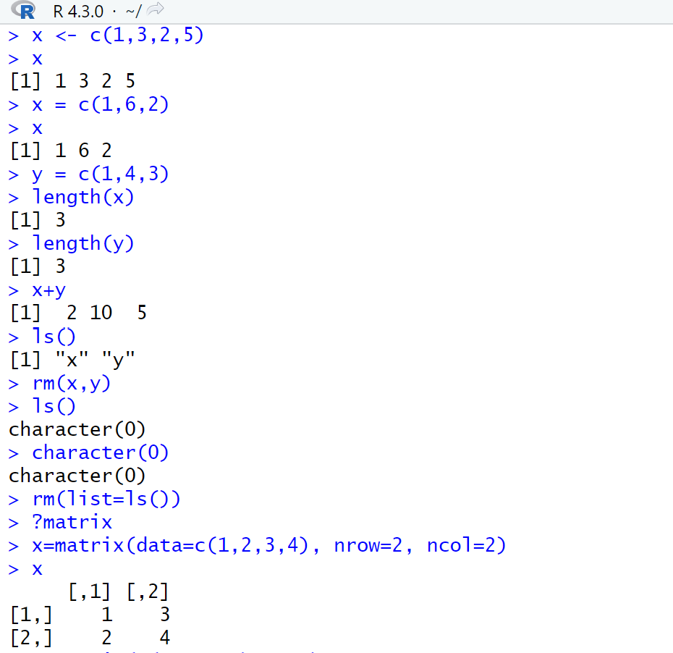

CODE:

x=matrix(c(1,2,3,4) ,2,2)

matrix(c(1,2,3,4) ,2,2,byrow=TRUE)

sqrt(x)

x^2

x=rnorm(50)

y=x+rnorm(50,mean=50,sd=.1)

cor(x,y)

set.seed(1303)

rnorm(50)

set.seed(3)

y=rnorm(100)

mean(y)

var(y)

sqrt(var(y))

sd(y)

OUTPUT:

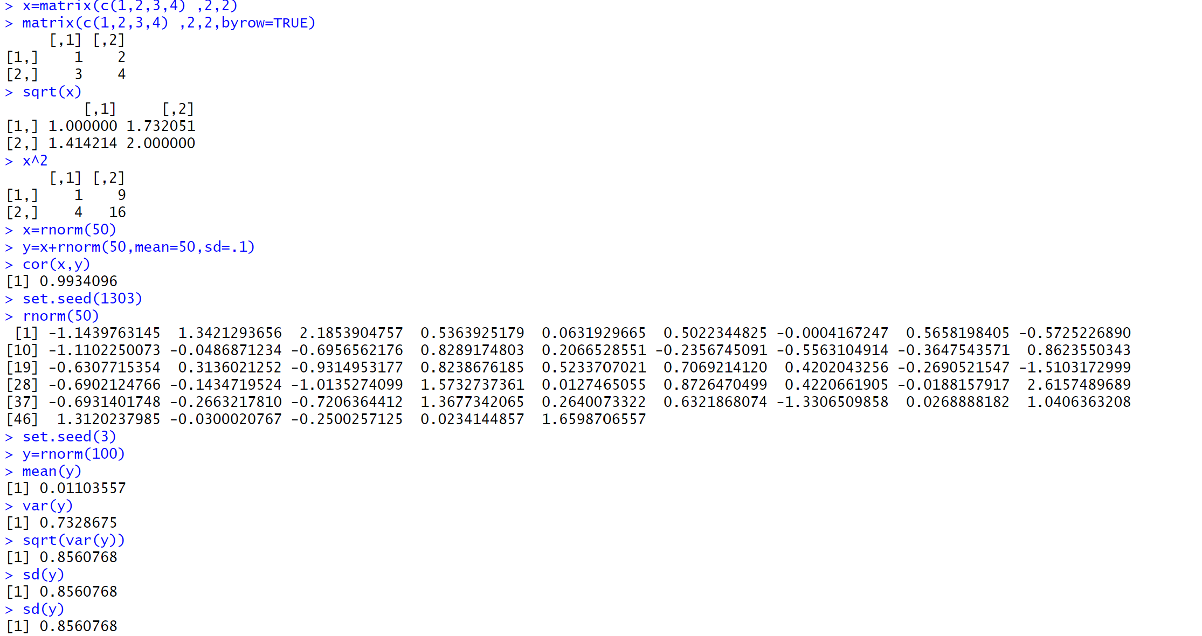

GRAPHICS IN R:

DESCRIPTION: The plot() function is the primary way to plot data in R . For instance, plot(x,y) produces a scatterplot of the numbers in x versus the numbers in y . There are many additional options that can be passed in to the plot() function.

CODE:

x=rnorm(100)

y=rnorm(100)

plot(x,y)

plot(x,y,xlab="this is the x-axis",ylab="this is the y-axis", main="Plot of X vs Y")

pdf("Figure.pdf")

plot(x,y,col="green")

dev.off()

x=seq(1,10)

x

x=1:10

x

OUTPUT:

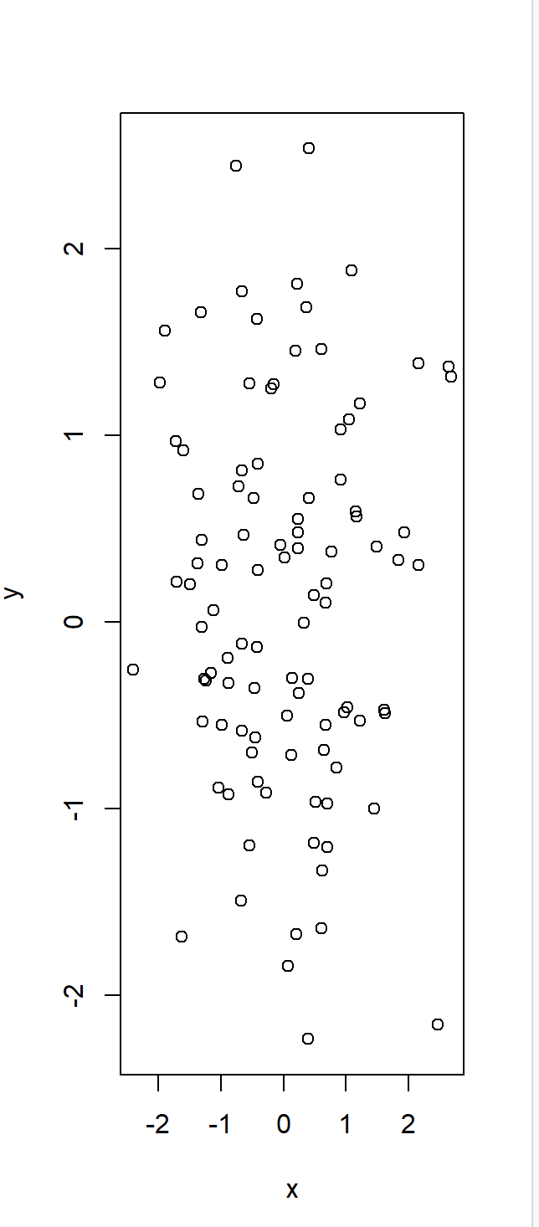 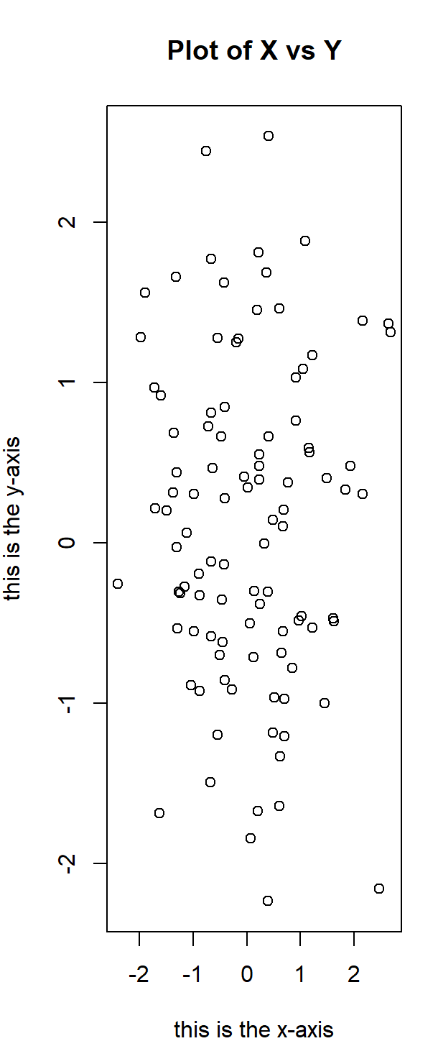

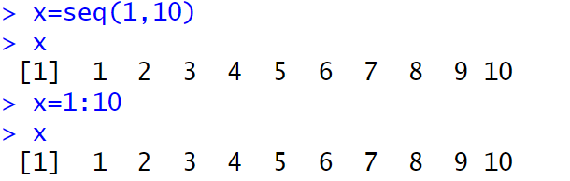

CODE:

x=seq(-pi,pi,length =50)

y=x

f=outer(x,y,function(x,y)cos(y)/(1+x^2))

contour(x,y,f)

contour(x,y,f,nlevels=45,add=T)

fa=(f-t(f))/2

contour(x,y,fa,nlevels=15)

OUTPUT:

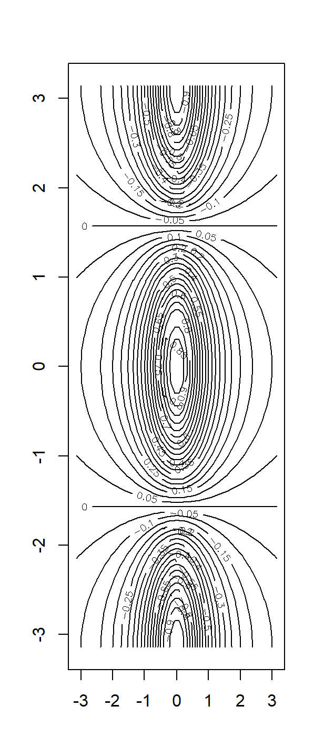 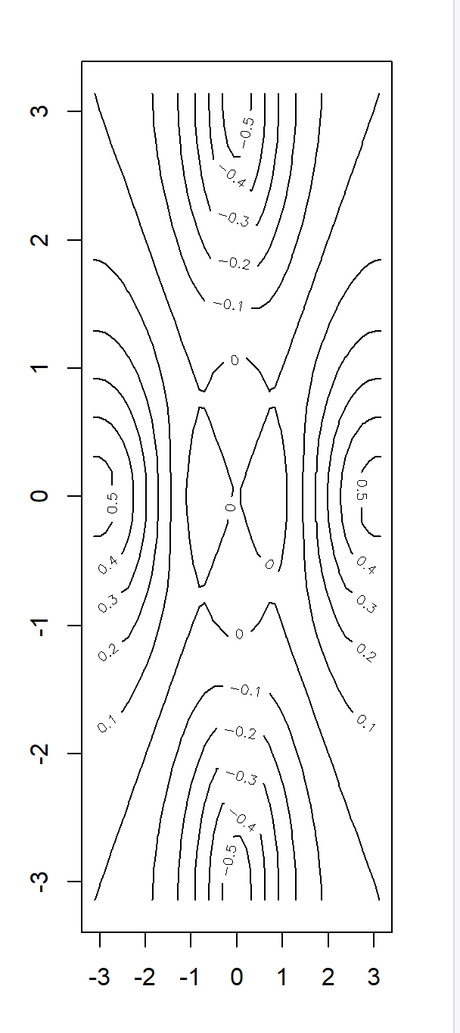

CODE:

image(x,y,fa)

persp(x,y,fa)

persp(x,y,fa,theta =30)

persp(x,y,fa,theta=30,phi=20)

OUTPUT:

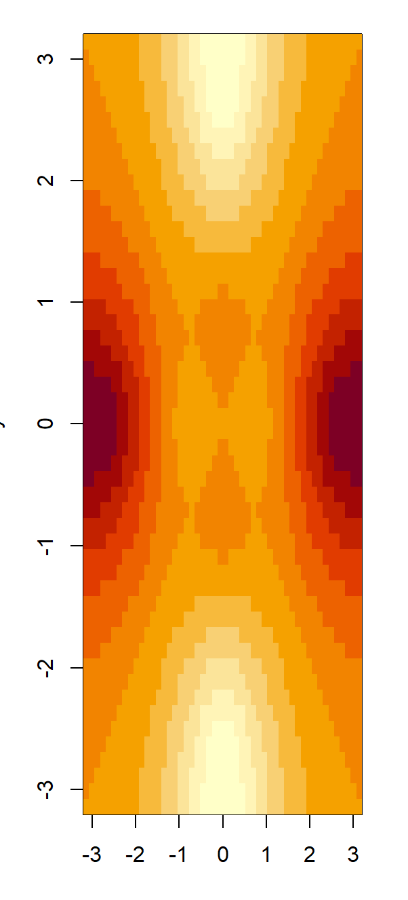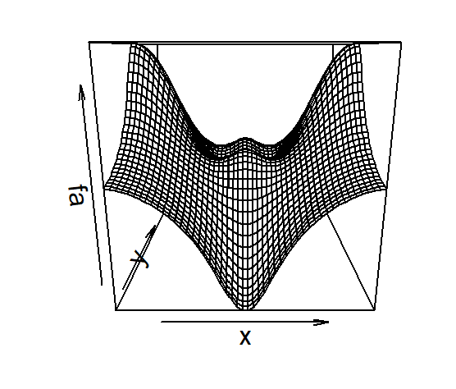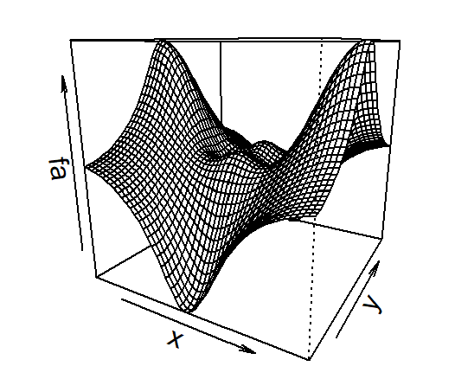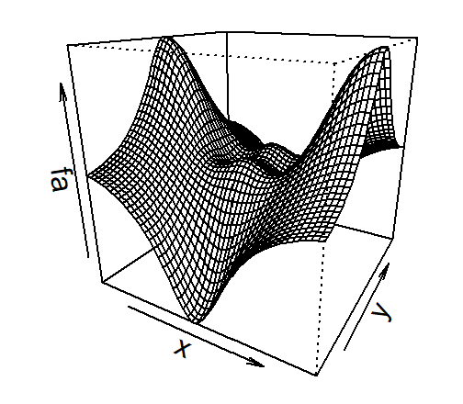

CODE:

persp(x,y,fa,theta=30,phi=70)

persp(x,y,fa,theta=30,phi=40)

OUTPUT:

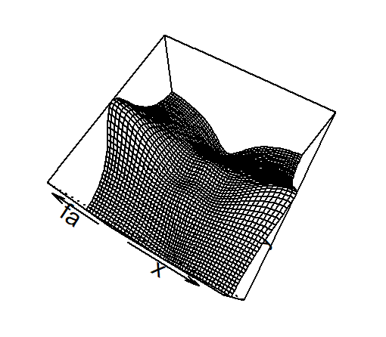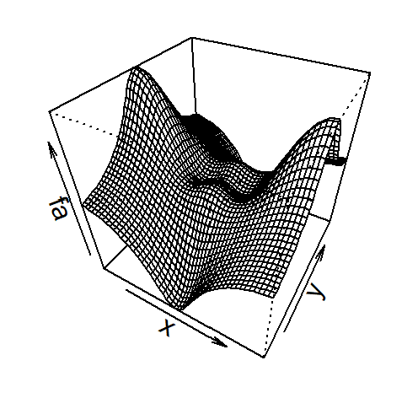

INDEXING DATA:

DESCRIPTION: We often wish to examine part of a set of data. Suppose that our data is stored in the matrix A .

CODE:

A=matrix(1:16,4,4)

A

A[2,3]

A[c(1,3),c(2,4)]

A[1:3,2:4]

A[1:2,]

OUTPUT:

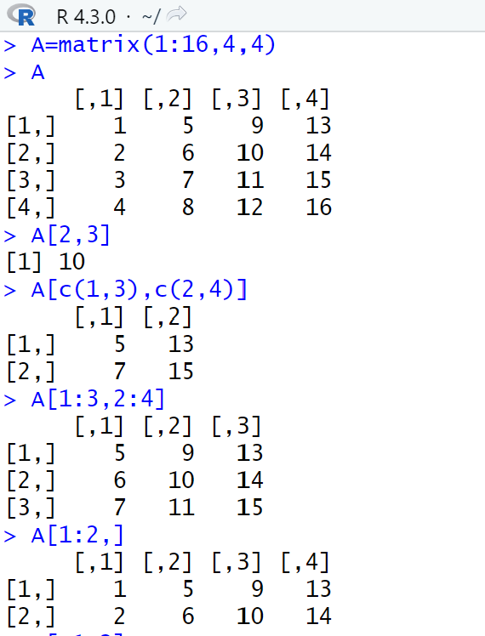

CODE:

A[,1:2]

A[1,]

A[-c(1,3),]

A[-c(1,3),-c(1,3,4)]

dim(A)

OUTPUT:

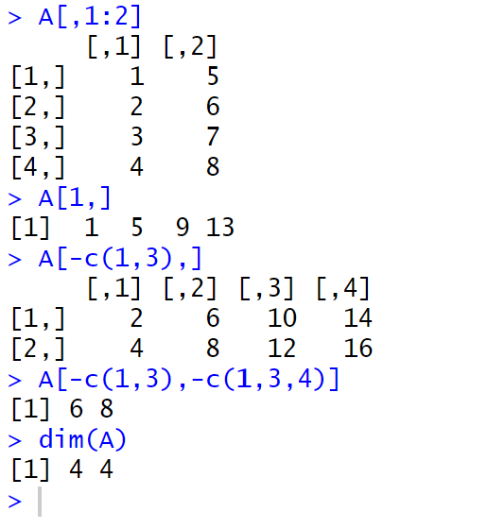

LOADING DATA:

DESCRIPTION:For most analyses, the first step involves importing a data set into R . The read.table() function is one of the primary ways to do this. The help file read.table() contains details about how to use this function. We can use the function write.table() to export data.

CODE:

auto<- read_excel("C:/Users/Hp/OneDrive/Desktop/ML/auto_mpg.csv.xlsx")

str(auto)

auto[1:4,]

auto=na.omit(auto)

dim(auto)

names(auto)

OUTPUT:

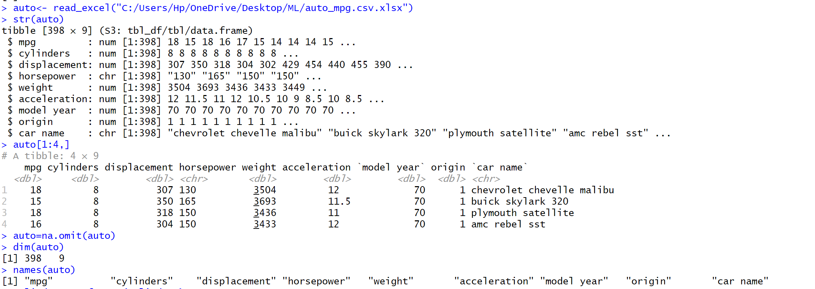

ADDITIONAL GRAPHICAL AND NUMERICAL SUMMARIES :

DESCRIPTION:We can use the plot() function to produce scatterplots of the quantitative variables. However, simply typing the variable names will produce an error message, because R does not know to look in the Auto data set for those variables.

CODE:

attach(auto)

plot(cylinders, mpg)

cylinders=as.factor(cylinders)

plot(cylinders,mpg)

OUTPUT:

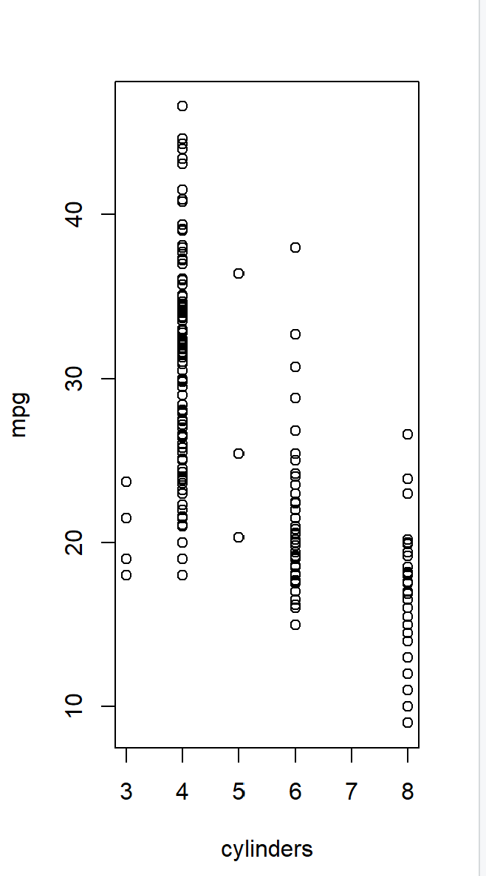 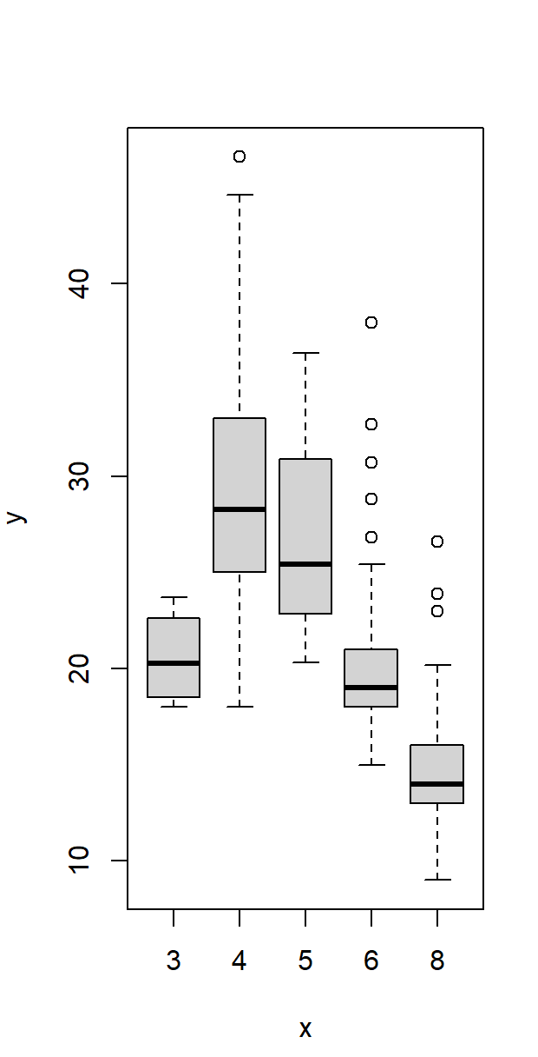

CODE:

plot(cylinders,mpg,col="red")

plot(cylinders,mpg,col="red",varwidth=T)

OUTPUT:

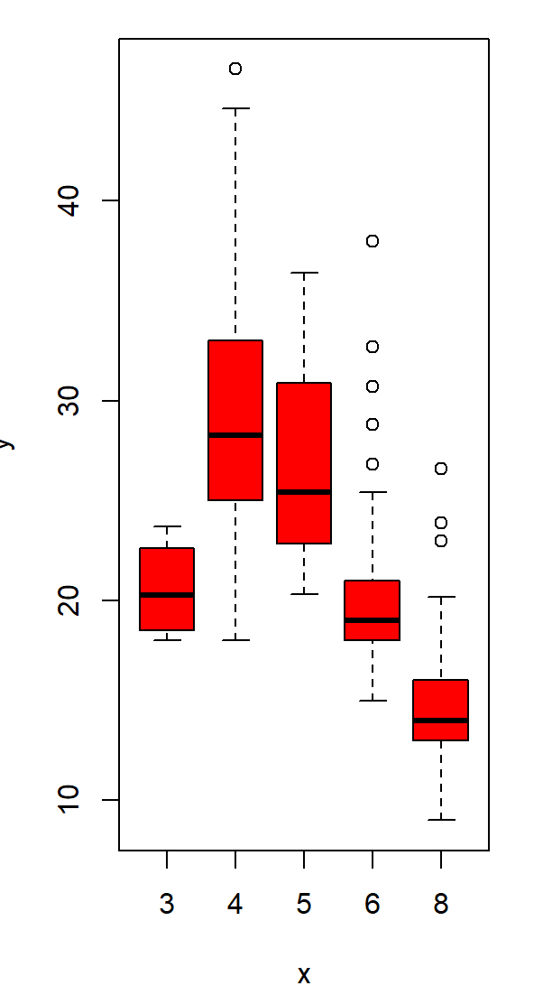

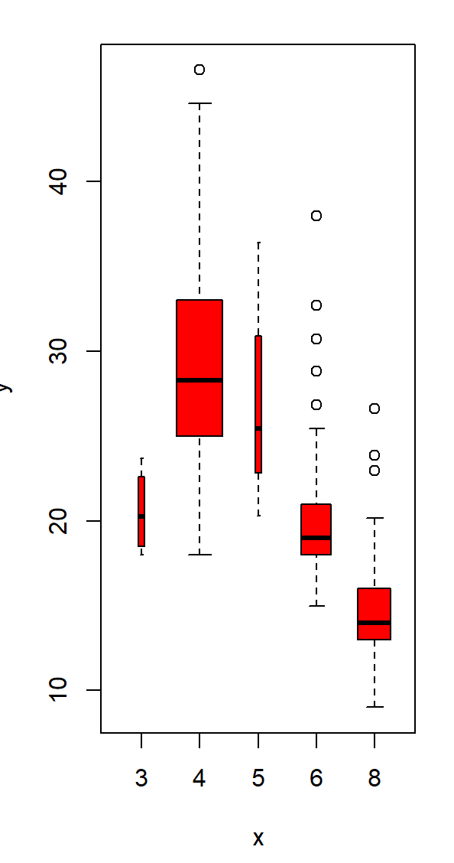

CODE:

plot(cylinders,mpg,col="red",varwidth=T,horizontal =T)

plot(cylinders,mpg,col="red",varwidth=T,xlab="cylinders",ylab="MPG")

OUTPUT:

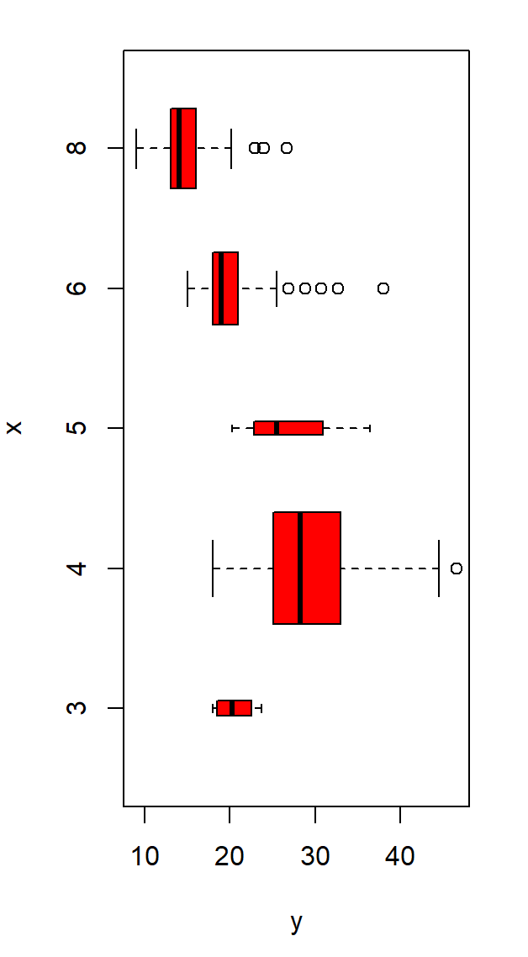

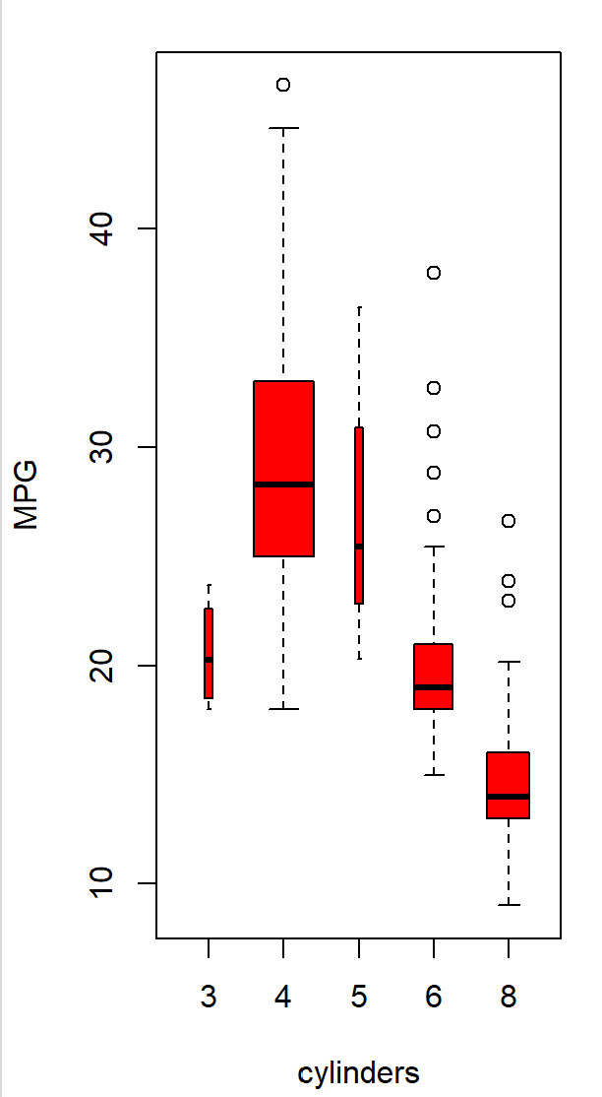

CODE:

hist(mpg)

hist(mpg,col=2)

OUTPUT:

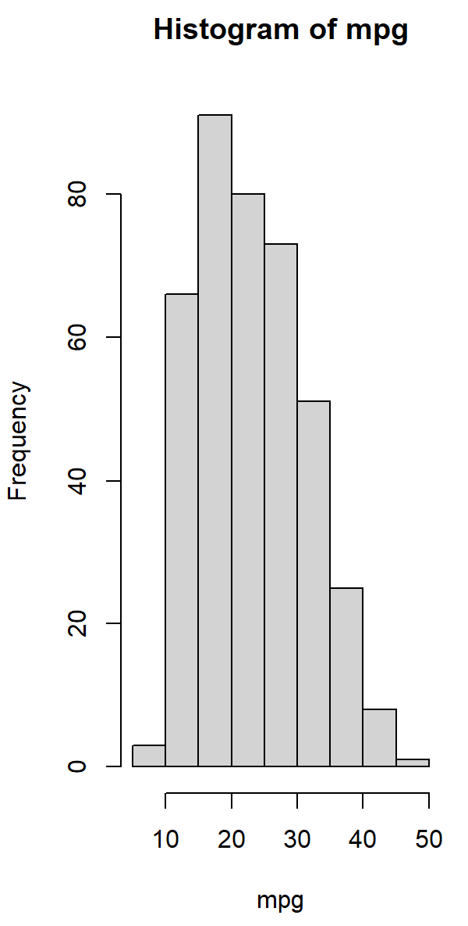

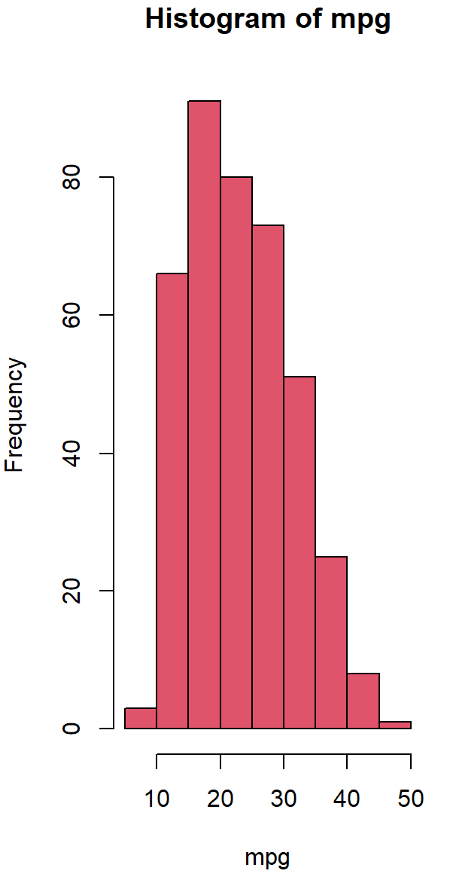

CODE:

hist(mpg,col=2,breaks=15)

plot(horsepower,mpg)

OUTPUT:

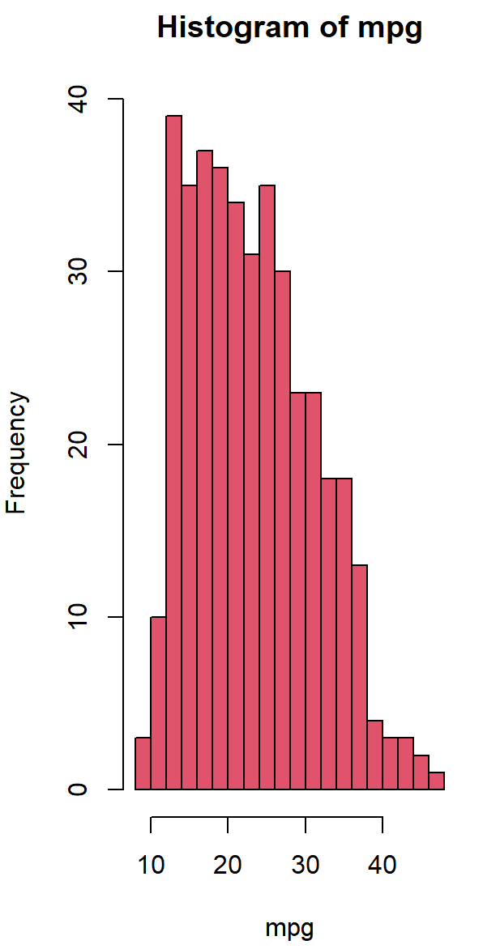

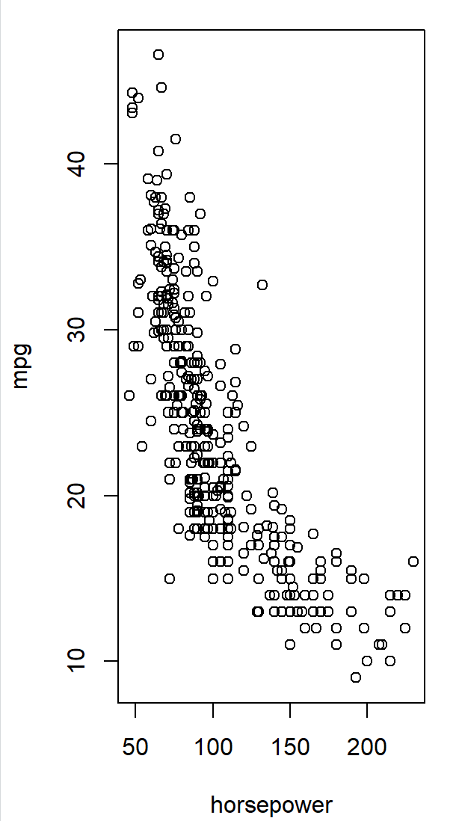

CODE:

identify(horsepower,mpg,car.name)

summary(auto)

summary(auto$mpg)

OUTPUT:

